Lab Report No 6

Convolution in Discrete Domain
Digital Signal Processing



Submitted By:
[Huzaifa Shahbaz]
[21-CE-009]
Submitted To:
Engg. Hareem Khan

Dated:
5thMarch,2024

Department of Computer Engineering,
HITEC University, Taxila
Lab Example 1:

Solution:
Brief description (3-5 lines)
Convolution Process:
The n dependency of y[n] deserves some care: for each value of n the convolution sum must be computed separately over all values of a dummy variable m each n.
1. Rename the independent variable as m. You now have x[m] and h[m]. Flip h[m] over the origin. This is h[-m]
2. Shift h[-m] as far left as possible to a point n where the two signals barely touch. This is h[n-m]
3. Multiply the two signals and sum over all values of m. This is the convolution sum for the specific n picked above.
4. Shift / move h[-m] to the right by one sample, and obtain a new h[n-m]. Multiply and sum over all m. 5. Repeat 2~4 until h[n-m] no longer overlaps with x[m], i.e., shifted out of the x[m] zone.
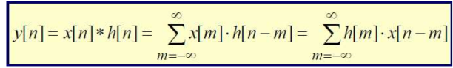
The code
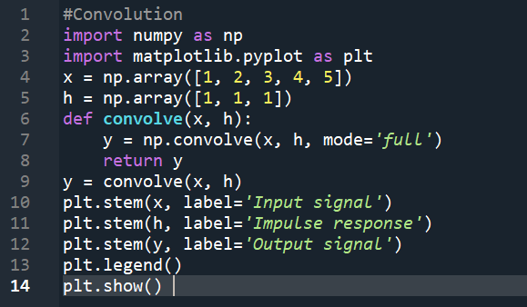
The results (Screenshot)
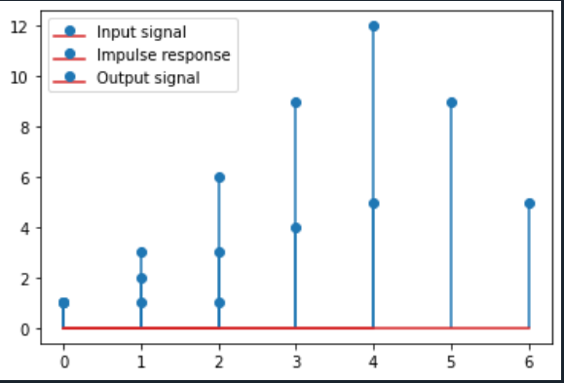
Lab Example 2:

Solution:
Brief description (3-5 lines)
Convolution Process:
The n dependency of y[n] deserves some care: for each value of n the convolution sum must be computed separately over all values of a dummy variable m each n.
1. Rename the independent variable as m. You now have x[m] and h[m]. Flip h[m] over the origin. This is h[-m]
2. Shift h[-m] as far left as possible to a point n where the two signals barely touch. This is h[n-m]
3. Multiply the two signals and sum over all values of m. This is the convolution sum for the specific n picked above.
4. Shift / move h[-m] to the right by one sample, and obtain a new h[n-m]. Multiply and sum over all m. 5. Repeat 2~4 until h[n-m] no longer overlaps with x[m], i.e., shifted out of the x[m] zone.

The code
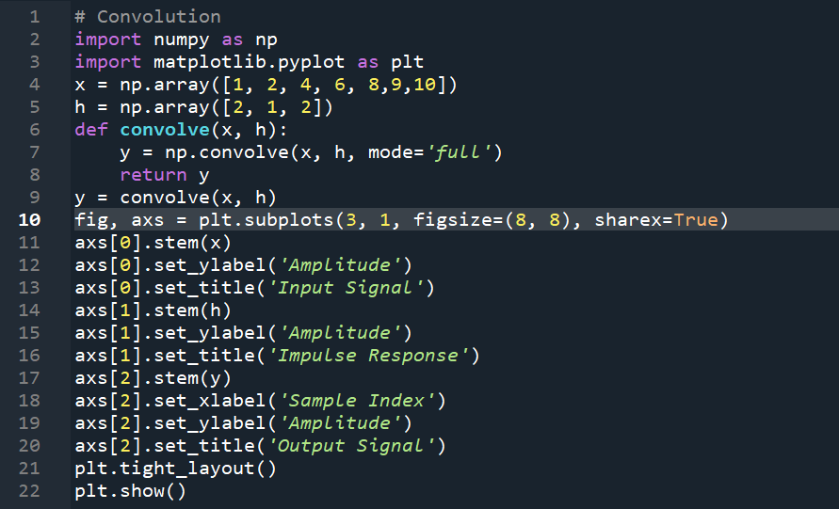
The results (Screenshot)
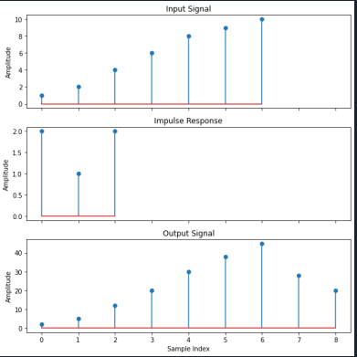
Lab Example 3:

Solution:
Brief description (3-5 lines)
Convolution Process:
The n dependency of y[n] deserves some care: for each value of n the convolution sum must be computed separately over all values of a dummy variable m each n.
1. Rename the independent variable as m. You now have x[m] and h[m]. Flip h[m] over the origin. This is h[-m]
2. Shift h[-m] as far left as possible to a point n where the two signals barely touch. This is h[n-m]
3. Multiply the two signals and sum over all values of m. This is the convolution sum for the specific n picked above.
4. Shift / move h[-m] to the right by one sample, and obtain a new h[n-m]. Multiply and sum over all m. 5. Repeat 2~4 until h[n-m] no longer overlaps with x[m], i.e., shifted out of the x[m] zone.

The code
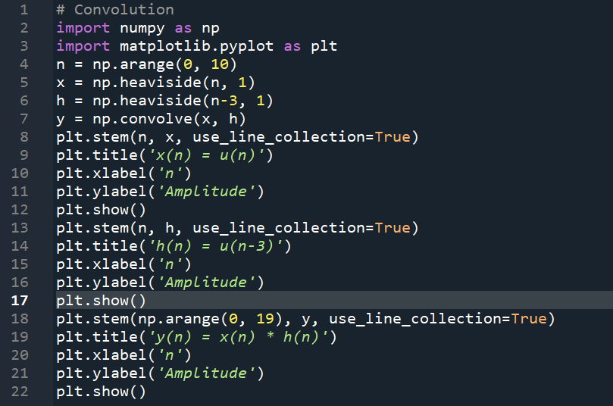
The results (Screenshot)
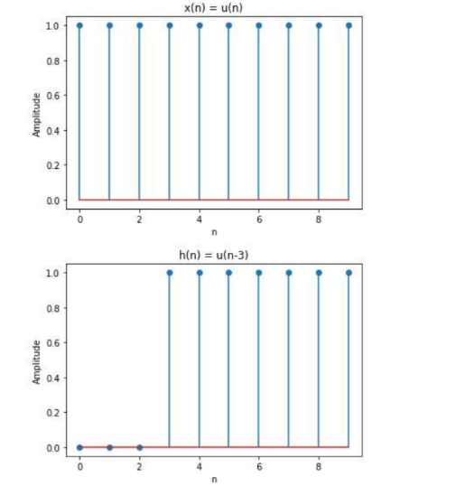

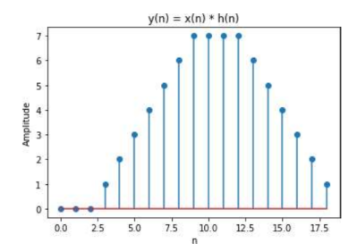
Lab Task No 1:

Solution:
Brief description (3-5 lines)
Consider a system with unit sample response.
h(n) = u(n)a^n
Find the response to an input x(n) = u(n) u-(n-N) find the convolution.
The code
# Convolution
import numpy as np
import matplotlib.pyplot as plt
def h_n(n, a):
return np.where(n >= 0, a ** n, 0)
def x_n(n, N):
return np.where((n >= 0) & (n <= N), 1, 0)
def convolution(x, h):
N1 = len(x)
N2 = len(h)
N = N1 + N2 - 1
y = np.zeros(N)
for n in range(N):
for k in range(max(0, n - N2 + 1), min(N1, n + 1)):
y[n] += x[k] * h[n - k]
return y
a = 0.5
N = 10
n = np.arange(0, 2 * N)
x = x_n(n, N)
h = h_n(n, a)
y = convolution(x, h)
plt.figure(figsize=(10, 6))
plt.subplot(3, 1, 1)
plt.stem(n, x, label='$x(n)$')
plt.xlabel('$n$')
plt.ylabel('Amplitude')
plt.title('Input Signal')
plt.subplot(3, 1, 2)
plt.stem(n, h, label='$h(n)$', linefmt='r-', markerfmt='ro', basefmt='r-')
plt.xlabel('$n$')
plt.ylabel('Amplitude')
plt.title('Impulse Response')
plt.subplot(3, 1, 3)
plt.stem(np.arange(0, len(y)), y, label='$y(n)$', linefmt='g-', markerfmt='go', basefmt='g-')
plt.xlabel('$n$')
plt.ylabel('Amplitude')
plt.title('Output Signal')
plt.tight_layout()
plt.show()
The results (Screenshot)
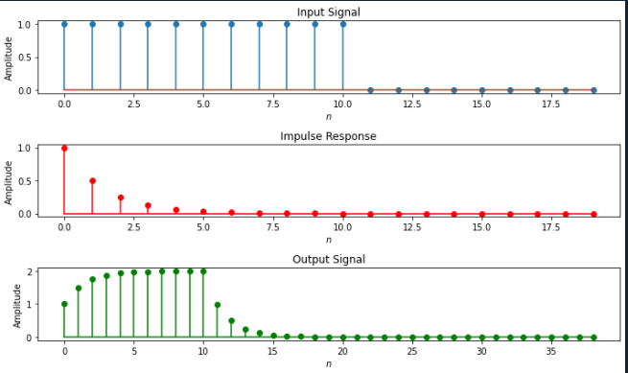
Lab Task No 2:

Solution:
Brief description (3-5 lines)
Find the convolution of
x(n) = (1/2)^n*u(n),
h(n) =u(n)- u(n 10)
The code
# Convolution
import numpy as np
import matplotlib.pyplot as plt
def input_signal(n):
return (1/2)**n * (n >= 0).astype(int)
def impulse_response(n):
return ((n >= 0).astype(int)) - ((n - 10) >= 0).astype(int)
def convolution(x, h):
return np.convolve(x, h, mode='full')
n = np.arange(0, 20)
x_n = input_signal(n)
h_n = impulse_response(n)
y_n = convolution(x_n, h_n)
plt.figure(figsize=(10, 6))
plt.subplot(3, 1, 1)
plt.stem(n, x_n)
plt.title('Input Signal x(n)')
plt.xlabel('n')
plt.ylabel('Amplitude')
plt.subplot(3, 1, 2)
plt.stem(n, h_n)
plt.title('Impulse Response h(n)')
plt.xlabel('n')
plt.ylabel('Amplitude')
plt.subplot(3, 1, 3)
plt.stem(np.arange(0, len(y_n)),y_n)
plt.title('Output Signal y(n)')
plt.xlabel('n')
plt.ylabel('Amplitude')
plt.tight_layout()
plt.show()
The results (Screenshot)
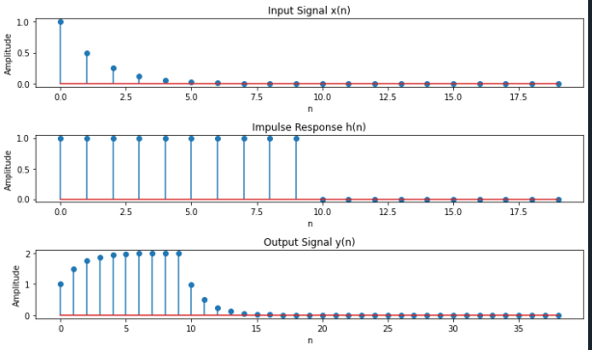
Lab Task No 3:

Solution:
Brief description (3-5 lines)
Find the convolution of
x(n) = (1/3)^-n*u(-n-1),
h(n) = u(n-1)
The code
# Convolution
import numpy as np
import matplotlib.pyplot as plt
def x(n):
return (1/3)**(-n) * (n >= 0)
def h(n):
return (n >= 1)
n = np.arange(-10, 10)
convolution_result = np.convolve(x(n), h(n), mode='full')
plt.figure(figsize=(10, 6))
plt.subplot(3, 1, 1)
plt.stem(n, x(n))
plt.title('Input Signal x(n)')
plt.xlabel('n')
plt.ylabel('Amplitude')
plt.subplot(3, 1, 2)
plt.stem(n, h(n))
plt.title('Impulse Response h(n)')
plt.xlabel('n')
plt.ylabel('Amplitude')
conv_n = np.arange(n[0]*2, n[-1]*2 + 1)
plt.subplot(3, 1, 3)
plt.stem(conv_n, convolution_result)
plt.title('Convolution Result')
plt.xlabel('n')
plt.ylabel('Amplitude')
plt.tight_layout()
plt.show()
The results (Screenshot)
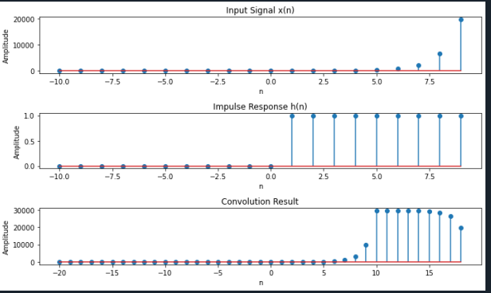
Lab Task No 4:

Solution:
Brief description (3-5 lines)
Find the convolution of
x(n) = (1/3) ^-n*u(-n-1),
h(n) = u(n-1) - u(n 2)+ u(n + 3)
The code
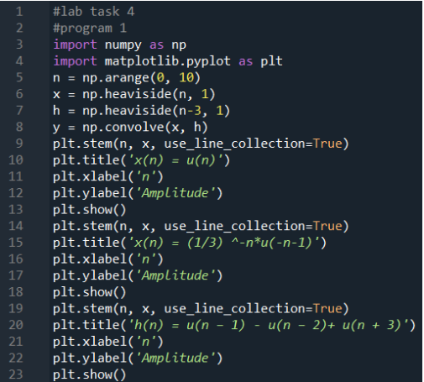
The results (Screenshot)
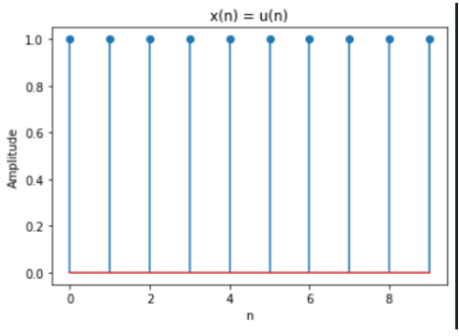
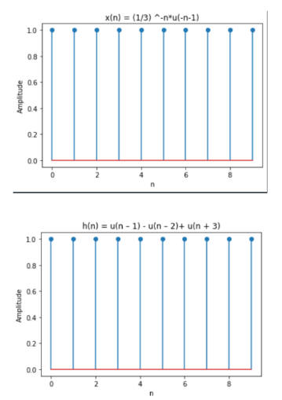
Lab Task No 5(a):

Solution:
Brief description (3-5 lines)
Find the convolution of
y(n)=sin(nπ/2) u(n)*u(n-2)
The code
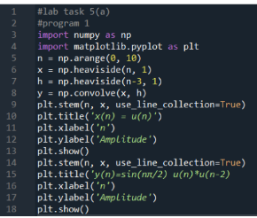
The results (Screenshot)
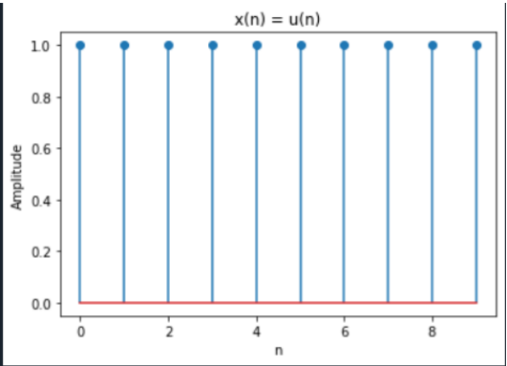
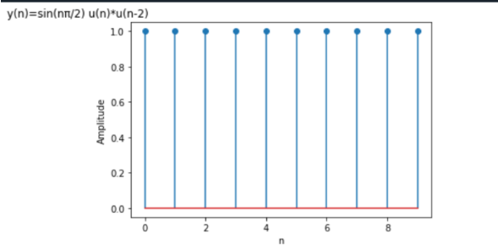
Lab Task No5(b):

Solution:
Brief description (3-5 lines)
Find the convolution of
y(n)=3^{n}u(-n+3)*u(n-2)
The code
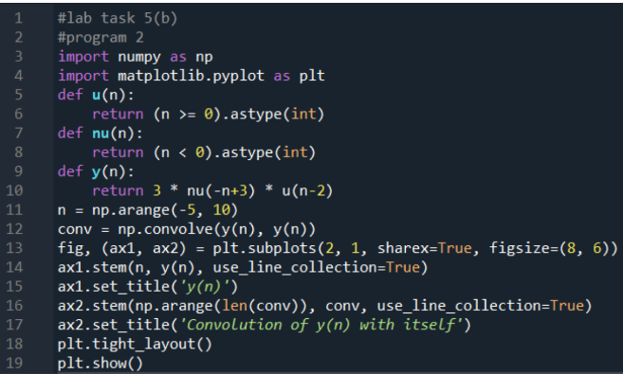
The results (Screenshot)
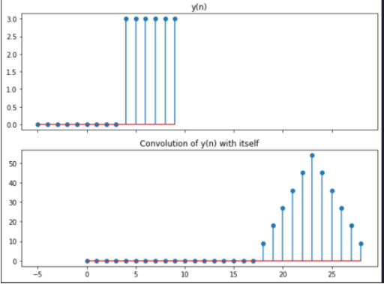
Lab Task No 6:

Solution:
Brief description (3-5 lines)
Find the convolution of
y(n)=3*nu(-n+3)*u(n-2)
x(n)=3*nu(-n+3)
h(n)=u(n-2)
The code
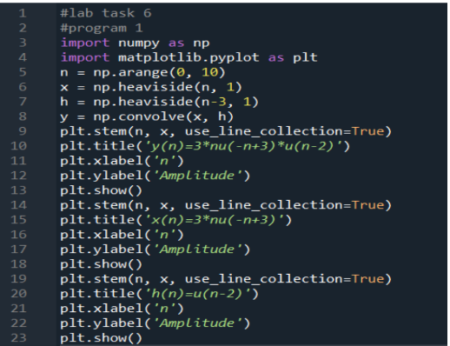
The results (Screenshot)
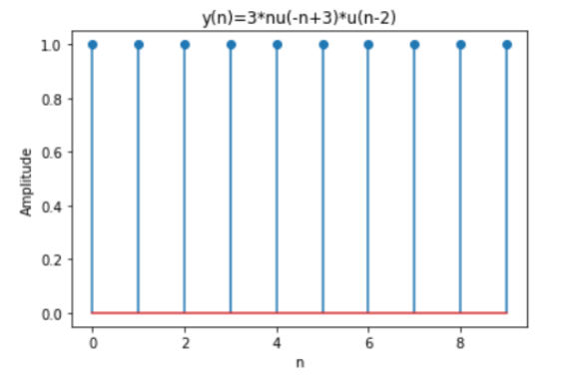
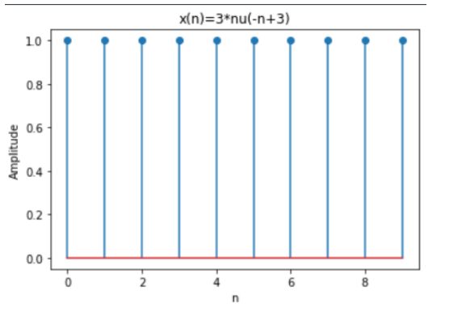
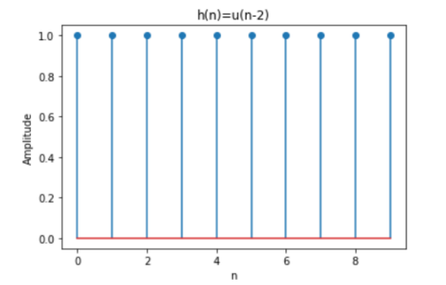
Conclusion
In conclusion, convolution in discrete domain is a powerful tool for processing digital data and extracting useful information from it.We also know the working and function of Convolution in Discrete Domain.

